Task 2
Insert, Update, Delete and Null Handling in SQL

INSERT INTO Authors (AuthorName,Country,BirthYear) VALUES
('J.K. Rowling','United Kingdom',1965),
('George Orwell','United Kingdom',1903),
('Chetan Bhagat','India',1974),
('R.K. Narayan','India',1906),
('Paulo Coelho','Brazil',1947),
('Dan Brown','United States',1964),
('Jane Austen','United Kingdom',1775),
('Yuval Noah Harari','Israel',1976);

Select * from Authors;
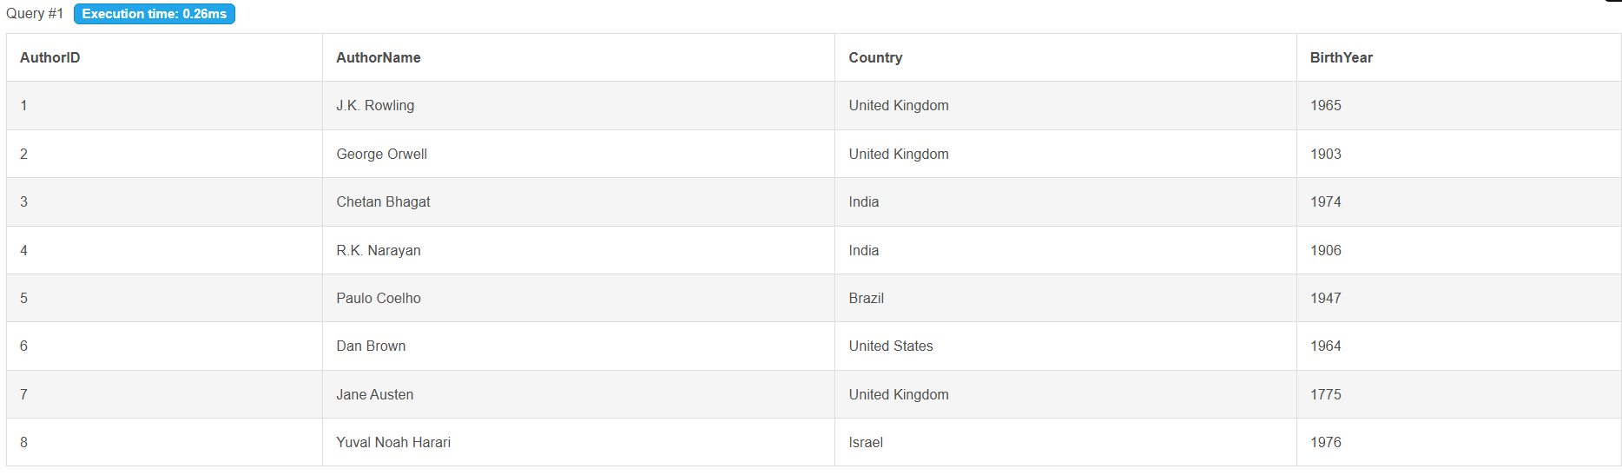

INSERT INTO Members(FullName,Phone,Email,MembershipDate,Status) VALUES
('Aarav Sharma','9876543210','aarav@gmail.com','2025-01-10','Active'),
('Priya Singh',NULL,'priya@gmail.com','2025-02-12','Active'),
('Rahul Verma','9876543211',NULL,'2025-03-01','Inactive'),
('Neha Gupta','9876543212','neha@gmail.com','2025-03-05','Active'),
('Rohan Mehta',NULL,NULL,'2025-03-20','Active'),
('Sneha Kapoor','9876543213','sneha@gmail.com','2025-04-01','Active'),
('Aditya Jain','9876543214','aditya@gmail.com','2025-04-15','Active'),
('Simran Kaur','9876543215',NULL,'2025-05-01','Inactive'),
('Karan Malhotra','9876543216','karan@gmail.com','2025-05-10','Active'),
('Ananya Das',NULL,'ananya@gmail.com','2025-05-15','Active');

SELECT * FROM Members;
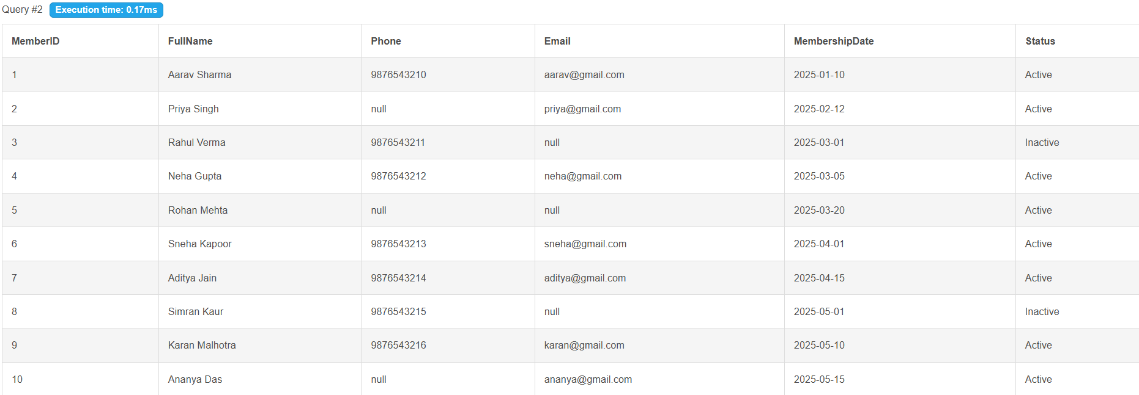

INSERT INTO Books(Title,AuthorID,ISBN,Category,PublishedYear,CopiesAvailable,Description) VALUES
('Harry Potter',1,'ISBN001','Fantasy',1997,5,'Wizard story'),
('1984',2,'ISBN002','Dystopian',1949,3,'Classic novel'),
('Animal Farm',2,'ISBN003','Political',1945,2,NULL),
('Five Point Someone',3,'ISBN004','Fiction',2004,4,'College life'),
('Malgudi Days',4,'ISBN005','Classic',1943,2,NULL),
('The Alchemist',5,'ISBN006','Fiction',1988,6,'Inspirational'),
('Inferno',6,'ISBN007','Thriller',2013,3,'Mystery'),
('Pride and Prejudice',7,'ISBN008','Romance',1813,2,NULL),
('Sapiens',8,'ISBN009','History',2011,5,'Human evolution'),
('Digital Fortress',6,'ISBN010','Thriller',1998,3,NULL),
('Brida',5,'ISBN011','Fiction',1990,2,NULL),
('Emma',7,'ISBN012','Classic',1815,2,NULL),
('The Guide',4,'ISBN013','Classic',1958,1,NULL),
('Revolution 2020',3,'ISBN014','Fiction',2011,4,NULL),
('Homo Deus',8,'ISBN015','History',2015,5,'Future of mankind');

SELECT * FROM Books;
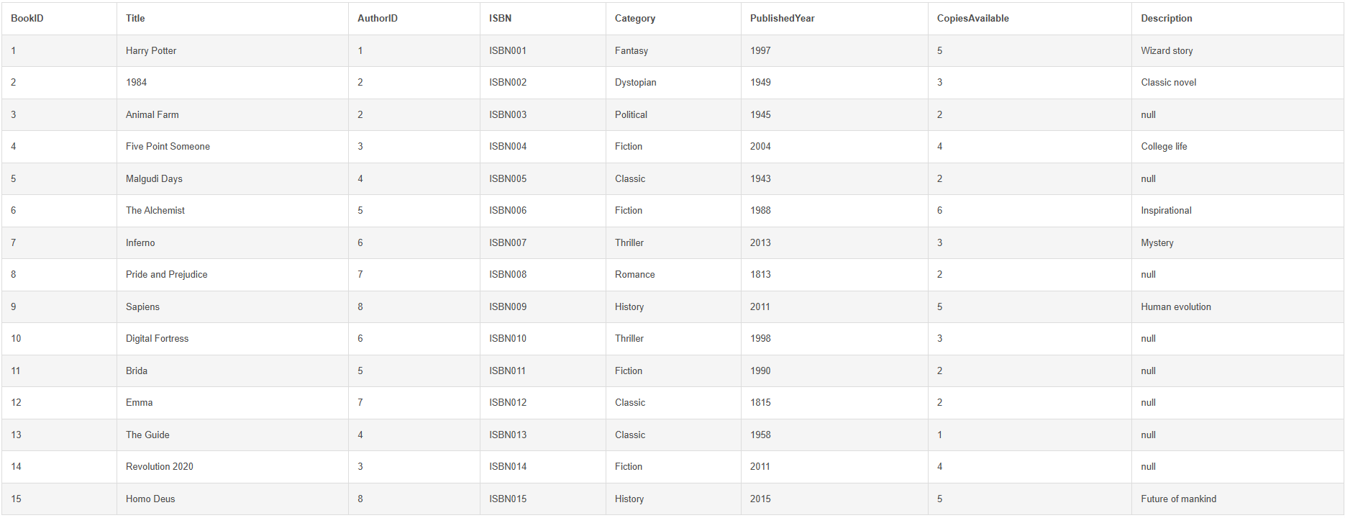

INSERT INTO BookIssues(MemberID,BookID,IssueDate,DueDate,ReturnDate,Fine) VALUES
(1,1,'2025-06-01','2025-06-15','2025-06-14',0),
(2,2,'2025-06-02','2025-06-16',NULL,0),
(3,3,'2025-06-03','2025-06-17','2025-06-20',50),
(4,4,'2025-06-04','2025-06-18',NULL,0),
(5,5,'2025-06-05','2025-06-19','2025-06-18',0),
(6,6,'2025-06-06','2025-06-20',NULL,0),
(7,7,'2025-06-07','2025-06-21','2025-06-22',20),
(8,8,'2025-06-08','2025-06-22',NULL,0),
(9,9,'2025-06-09','2025-06-23','2025-06-23',0),
(10,10,'2025-06-10','2025-06-24',NULL,0),
(1,11,'2025-06-11','2025-06-25',NULL,0),
(2,12,'2025-06-12','2025-06-26','2025-06-27',10);

SELECT * FROM BookIssues;
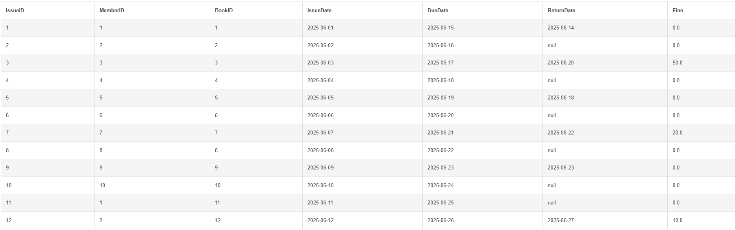

Update Statements
UPDATE Members SET Phone='9999999999' WHERE MemberID=2;
SELECT * FROM Members;
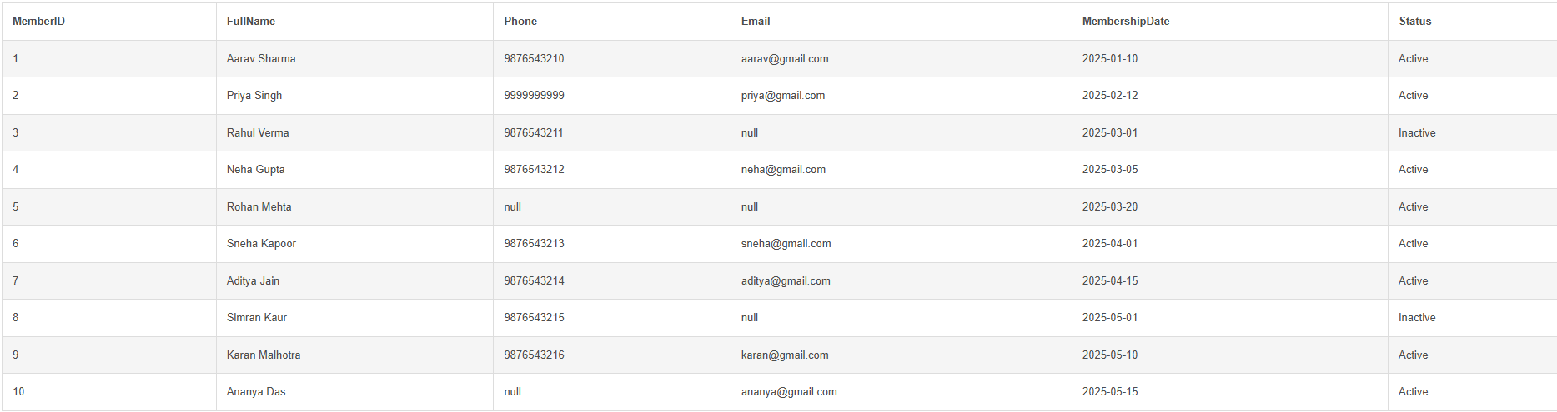
UPDATE Members SET Email='unknown@example.com' WHERE Email IS NULL AND MemberID=3;
SELECT * FROM Members;
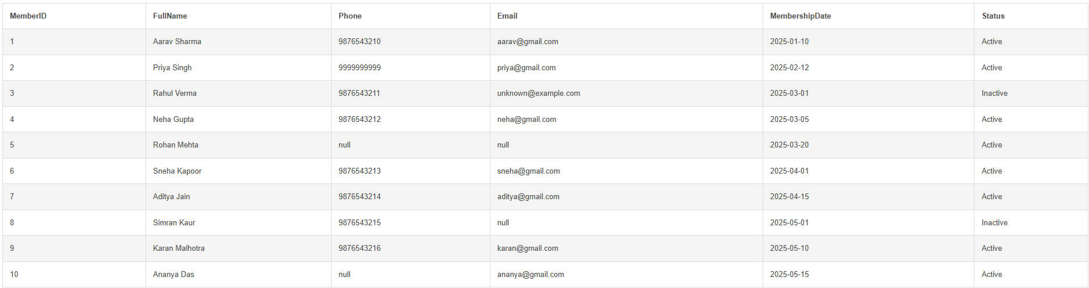

UPDATE Books SET CopiesAvailable=CopiesAvailable+1 WHERE Category='History';
SELECT * FROM Books;
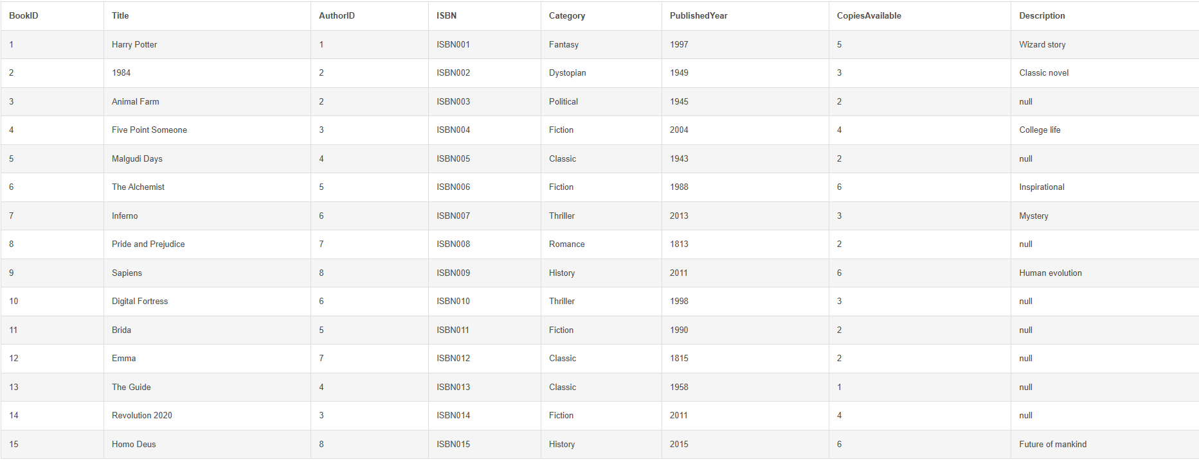

UPDATE Members SET Status='Active' WHERE Status='Inactive';
SELECT * FROM Members;
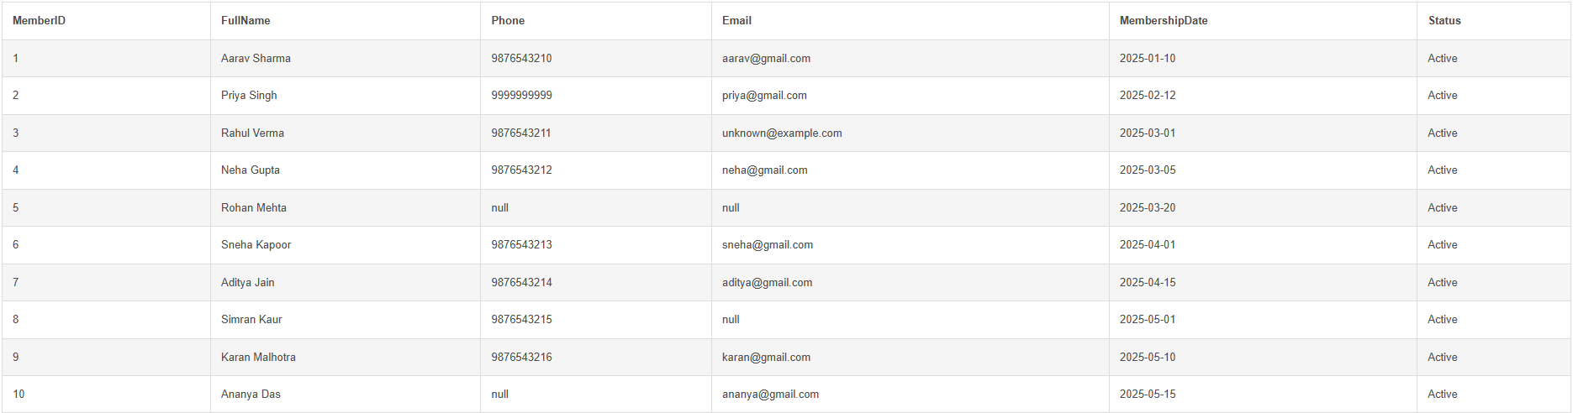

Null Statements and Null Handling
SELECT * FROM Members WHERE Phone IS NULL;

UPDATE Members Set Phone='9871073168' WHERE MemberID=5;
UPDATE Members Set Phone='9871072315' WHERE MemberID=10;
SELECT * FROM Members;
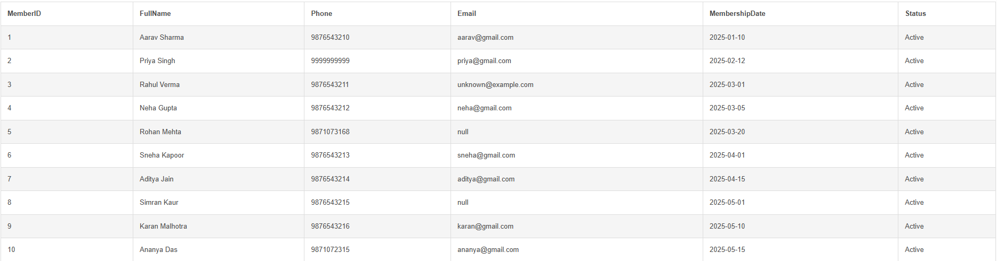

SELECT * FROM Members WHERE Email IS NOT NULL;
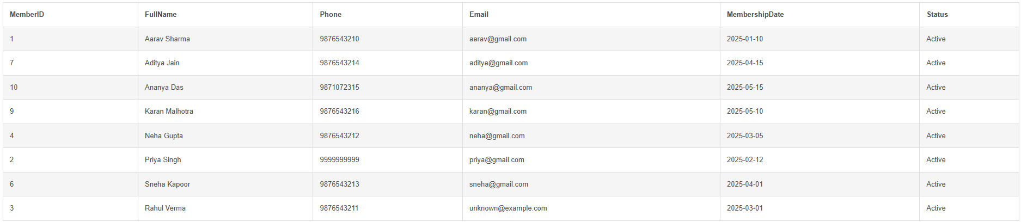

Delete Statements
DELETE FROM BookIssues WHERE Fine=0 AND ReturnDate IS NOT NULL;
SELECT * FROM BookIssues;
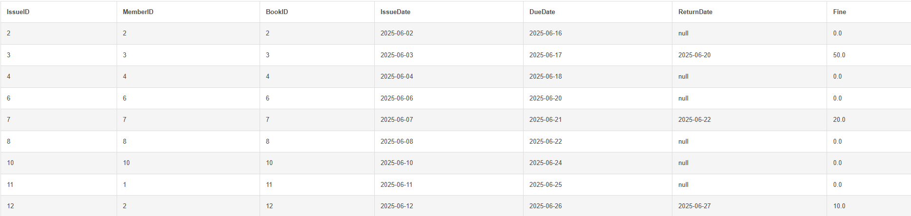
DELETE FROM Members WHERE FullName='Simran Kaur';
SELECT * FROM Members;
